1. 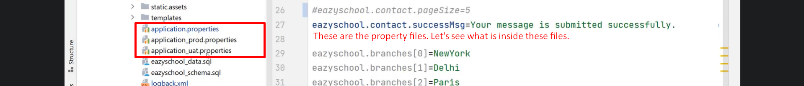
2. Text

   Description automatically generated
3. Graphical user interface, text, application, chat or text message

   Description automatically generated
4. Graphical user interface, text, application, email

   Description automatically generated
5. **NOTE**: Instead of defining separate file for each environment, we can put all those configuration inside application.properties along with delimiter.